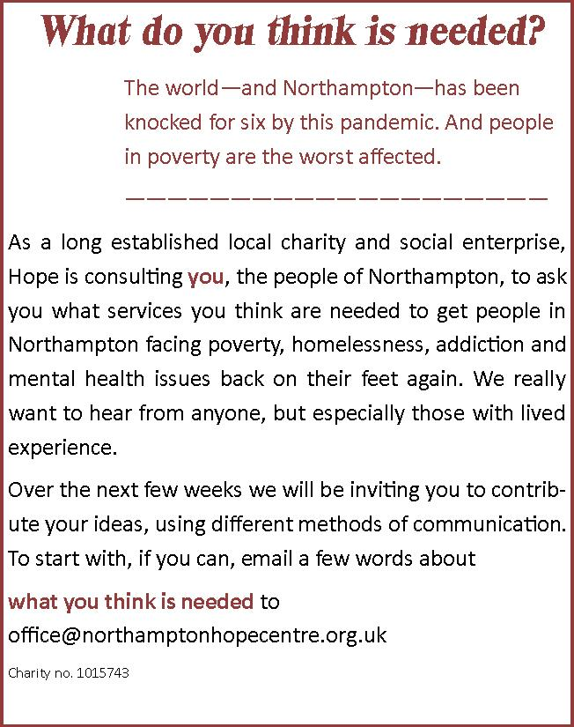

What do you think is needed by the people of Northampton, who are in most acute need? (use an extra sheet if needed)

