
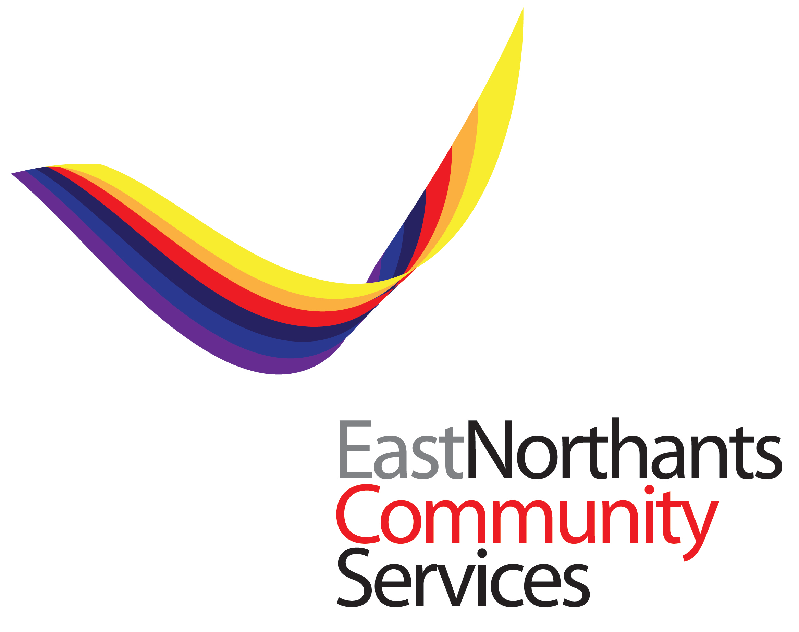



Press release – under embargo till 8th April ‘20

Emergency Alliance formed in food poverty fight

An appeal is today being launched by a quartet of local charities to feed the county’s most vulnerable, poor and disadvantaged who are the worst affected by the COVID-19 crisis.

The Northamptonshire Emergency Food Aid Alliance has set a target of raising £84,000 to provide 1,000 meals a day, every day, for at least the next three months to help support those most in need.

The partnership brings together Northampton’s Hope Centre, the Daylight Centre Fellowship in Wellingborough, East Northants Community Services, which serves the east of the county and Corby, and Accommodation Concern in Kettering and is now appealing for monetary donations for ready meals, which, with all those involved acting as volunteers, will fund only the cost of ingredients, packaging and delivery.

Rachel Mallows MBE DL is the Daylight Centre Fellowship’s Chair of Trustees and says there’s never been a more urgent need for support: “The county has some of the top 20% of deprived wards in the UK and this national emergency has only compounded their adversity, inequality and poverty to new and desperate levels” explained Rachel.

“This project will aim to address the issues for our most deprived communities and while we’ve already started to apply to trusts and other sources of finance for funding, those take time to be secured and time is something we simply don’t have.

“We need help now so that we can ensure that our isolated, elderly and those at risk don’t become ill due to hunger or, worse still, a further victim of this terrible disease” urged Rachel.

Meanwhile Robin Burgess, CEO of the Hope Centre, says that it’s great to see such organisations pulling together during such challenging times: “Thanks to this new collaboration, we will be able to access stocks of high-quality locally sourced ready meals to add to the food we already supply to people in need” said Robin.

“During this crisis we are supplying over two thousand meals a week to rough sleepers in hotels and a further 400 a week through our Hope Foodclub so, with the countywide increase in demand prompted by the current situation, we are really pleased to be working in partnership to produce a vital food resource" he added.

The Alliance is working in conjunction with Northamptonshire’s Community Resilience Hubs to support those most at risk and to avoid duplicating efforts.

Its support will be targeted at those who are unable to prepare their own meals, for whom food parcels may be inappropriate, as well as the county’s rough sleepers who have now been found shelter through their local council and, crucially, the meals will be created from fresh ingredients and cooked to order, thereby ensuring those who receive them benefit from at least one healthy, nutritious meal a day.

A number of local businesses have already generously responded to the call to arms, including a start-up donation of £6,000 from Northampton-based British Pepper & Spice, while Whitco Catering and Bakery Equipment in Thrapston is donating food and also joins Ray Hall of R H Hall Ltd in Bedfordshire and Barrie Mcnamee from Kitchen Clearance UK Ltd in Collyweston in being among those to have donated freezers and microwaves.

Additionally, Kettering catering company Portfolio Events are currently preparing the meals at cost, utilising chefs who are volunteering for this work.

A restricted fund has been set up and is now open for donations. Those can be paid to Daylight Centre; Sort Code 60-83-01; Account No. 20159054. (Charity No. 1100809)

For further information please email Rachel Mallows at rachel@themallowscompany.com

Ends

***

Notes to Editors:

About Accommodation Concern
Accommodation Concern, based in Kettering, is a dedicated, independent, housing and welfare benefit charity offering free and impartial advice via drop-in sessions and individual appointments, which uphold the Advice Quality Standards. The town's rough sleeper outreach workers are based with the charity and provide the required key work support. www.accommodationconcern.co.uk

About Daylight Centre Fellowship

Daylight Centre Fellowship is an independent local charity in the East Midlands. It strives to help people in Wellingborough and the surrounding districts of North Northamptonshire in meeting personal challenges that range from complex mental health issues, drug and alcohol abuse, learning difficulties, to homelessness or just feeling fragile, isolated and alone. www.daylightcf.org

About East Northamptonshire Community Services
East Northants Community Services is a registered charity that aims to support those experiencing homelessness, poverty and addiction. It does this through several projects that operate across the county. Its mission is to enable disadvantaged people to live independent and fulfilled lives and to empower and support individuals on their journey. www.encs.org.uk

About Hope Centre
Hope is a registered charity and company limited by guarantee, active in providing service for people in poverty and homelessness in Northampton since 1974. www.northamptonhopecentre.org.uk

