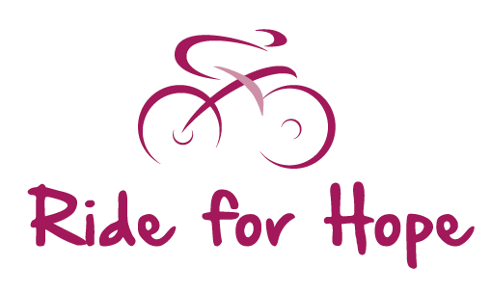


I am a rider:

I am support crew:
Please tick a box
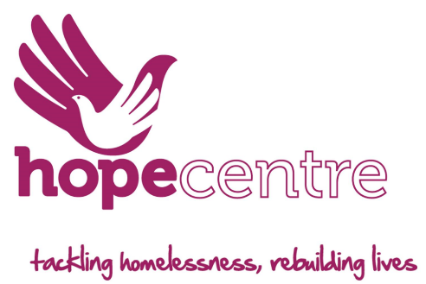
4 – 7 July 2019
Application Form

Full Name:
Address:
Date of birth: |  | Age:
E-mail: |  | Mobile No:
Next of Kin (NOK): |  | NOK Relationship:
NOK Address:
NOK Contact no: |  | NOK E-mail:
Are you a first aider: Yes/No |  | Shirt size: chest size:
Any dietary requirements:
Health:
Riders must make sure they are medically fit to take part in the bike ride. If in doubt, riders must get clearance from their GP before participating. There will be a full medical questionnaire to be completed before the ride.
Medical conditions:
Yes / No If YES, please specify:

Do you take Medication:
Yes/No If YES, please list:

Any other information you would like to add:

I am under 18 and this form has been signed by my parent / guardian. Please tick if appropriate

Person to contact in case you are involved in an emergency on the day:
Name: Number:
If you are a support driver using your own car for the event, please provide the following information:
Make and model: | Reg no: |  | MOT and insurance: Yes / No
Please sign and date this application form:
Signature: | Name: |  | Date:
Declaration:  I agree to abide by Terms & Conditions of the Ride for Hope Event for non-competitive cycling, and understand and agree that I participate in this event entirely at my own risk, that I must rely on my own ability in dealing with all hazards, and that I must ride in a manner which is safe to myself and others  I am aware that when riding on a public highway the function of marshals or group leaders is only to indicate direction and that I must decide whether the movement is safe.  I agree that no liability whatsoever shall attach to the promoter, charity, event sponsor or any event official or member of the Ride For Hope organising team in respect of any injury, loss or damage suffered by me in or by reason of the event however caused.  I will participate in cycling events in a loyal and sporting manner. |  | I will submit to disciplinary measures taken against me and will take any appeals and litigation to the Event Manger provided for in the Terms & Conditions.  Subject to that reservation, I shall submit to any dispute that may arise exclusively to the Ride For Hope Committee.  Waiver of Liability:  I have read, understood and agree to abide by the Terms and Conditions and the declarations listed in this form, and am entering the event at my own risk.  Please sign for agreement to the above statement and the Terms and Conditions of the Ride for Hope 2019 sent to you as a separate document:  Signature:  (no signature needed if returned electronically)  Date:
Application:  Send your completed Application Form and cheque to:  Louise Danielczuk  Email: Fundraising@northamptonhopecentre.org.uk  Tel: 0845 5199371  Application forms and non-refundable deposits must be received by: 1 June 2019  The balance will be paid by: 4 June 2019  Entry Fee = £275 Minimum Sponsorship Pledge £300 |  | Payment:  Payment by electronic transfer to:  - Hope Centre (Use your name as reference)  - Sort code 56-00-60  - Account number 78450586  Or cheques should be made payable to:  - The Northampton Hope Centre  Send an email confirmation of electronic payment to:  - fundraising@northamptonhopecentre.org.uk
By sending this application form back via e-mail without a signature,
you are deemed to have accepted the Ride for Hope 2019 Terms and Conditions
GDPR statement:
If you would like to receive regular information from The Hope Centre please tell us what you would like to receive
and how you would like to receive it.

I give Northampton Hope Centre and Hope enterprises permission to contact me in the following ways to keep me informed of future events and fundraising activities.
email |  | Post |  | SMS |  | Phone

